Constructor:

It is a special block which always get execute whenever we create an object.

There are 2 types of constructor:

a. default constructor.

b. user define constructor.

a. default constructor: If user doesn’t create a constructor inside a class then JVM will create a constructor. And that constructor doesn’t have any code available in it.

Public Nameofclass()

{

}

b. User define constructor: Whenever a constructor got defined by user inside a class is called user define constructor.

Example:

**public** **class** Test {

// syntax of constructor

// public classname()

// {

//

// }

**public** Test()

{

System.***out***.println("constructor is executing");

String s = "abc";

**int** i = 10;

System.***out***.println(s+i);

}

// above highlighted text is user defined constructor

**public** **void** m2()

{

}

**public** **static** **void** m1() {

System.***out***.println("m1 method");

}

**public** **static** **void** main(String[] args) {

Test t = **new** Test();

Test t1 = **new** Test();

t.m2();

}

}

**Rules of constructor:**

* Class name and constructor must be same.
* Constructor cannot have return type.
* We can have multiple constructors inside a class but their name must be same with different argument.
* Constructor can take the arguments.
* Constructor can call another constructor by using this keyword but that call must be at the first line.
* We can call only one constructor at a time inside another constructor.

Example to call another constructor using this keyword:

**public** **class** A {

// calling of constructor inside another construtor

**public** A()

{

System.***out***.println("zero argument construtor");

}

**public** A(**char** c)

{

**this**(50, "abc");

System.***out***.println("one argument construtor");

}

**public** A(**int** i, String s)

{

**this**();

System.***out***.println("two argument construtor");

}

**public** A(String s, **int** i)

{

System.***out***.println("two argument construtor");

}

**public** **static** **void** main(String[] args) {

A a1 = **new** A('a');

}

}

Output:

zero argument construtor

two argument construtor

one argument construtor

**Use of constructor:**

1. Whenever we want to execute any logic based on the object creation then we require a constructor.

2. It is used to initialize the data members.

Example:

**public** **class** B {

// in this class we will see the use of constructor:

String name ;

String nativeplace;

**int** mathsmarks;

**int** age;

**static** **int** *roll*;

**static** String *collegecity*;

**static** String *collegename*;

**public** B(String name, String nativeplace, **int** mathmarks, **int** age)

{

**this**.name = name;

**this**.nativeplace = nativeplace;

**this**.mathsmarks= mathmarks;

**this**.age= age;

}

**public** **static** **void** main(String[] args) {

B s1 = **new** B("Daniel", "Alaska", 50, 18);

B s2 = **new** B("Eder", "unioncity", 60, 19);

System.***out***.println(s2.age);

}

}

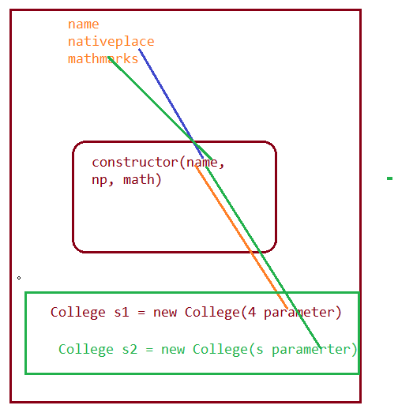

Difference between this and this():

this keyword is used to access the global variable inside the non-static area whereas this() is used to call a constructor inside another constructor.